ECE 09.203: Three Band Equalizer

Adil Khaleeli and Zachary Bravo

Rowan University

December 19, 2021

## Abstract

In this lab the goal was to create a three band equalizer composed of a high frequency pass filter, a medium frequency pass filter and a low frequency pass filter. The equalizer had to be made both as a schematic and a simulation within TINA, a spice circuit simulation program. Then the equalizer circuit would be printed and soldered for a physical test. The tests that would have been used were a continuity test, a measurement test and an audio test. These would determine if each band pass worked and if the circuit was properly soldered overall. However, as there was not enough time to print and solder the circuit it was instead created on a breadboard. This circuit then went through only an oscilloscope test and a continuity test.

This lab is separated into 4 parts, the introduction, the background, the results, and the conclusion. The introduction gives the problem faced in this lab and presents a couple solutions. It gives an introduction to the components and how they can be used. The background gives a detailed description of what methods were used to create each part of the circuit and our process in completing the given problem. It includes images of the circuit and explains certain design decisions. The results aim to describe what the simulation and physical test results mean. It shows whether the aimed goal was reached or if not, why it failed. Any errors or design decisions during any part of the design of the circuit or PCB are mentioned within the discussion of the parts.

## Table Of Contents

### Introduction………………………………….…….……………………….…………...3

### Background…………………………………………………………..………………….3

1. Capacitors and Inductors as Filters…………………………………………………...3
2. Passive vs Active Filter……………………………..……………………………….4

### Design ……………………………………………………………………..…………….4

1. Active Filter………………………………………………………..……………….4
2. Schematic Design…………………………………...………………………………4
3. The PCB Design……………………………………………………….……………6

#### Physical Design/Procedures……………………………………………….…………8

1. Setup of Breadboard………………………………………………………………...8
2. Setup of measuring equipment………………………………………………………9
3. Results………………………………………………………………………..…………10
4. Simulation……………………………………...…………………………………10
5. Breadboard Testing…………………………………………………...……………11

### Conclusions…………………….…………………...…………………………………14

### Appendix…………………….…………………...…………………………………….14

#### Oscilloscope settings….…………………...……………………………………..14

#### TINA settings….…………………...…………………………………………….16

1. Quad Op-Amp Datasheet….…………………...…………………………………..16
2. Aimed Frequency Values….…………………...…………………………………..16

## **Introduction**

The issue of a client wanting a specific frequency or loudness level to be maintained while giving a variety of audio signals is easily solved by a filter. The filter would cut off or suppress the sound of the audio at a known frequency point. To make this process more precise a 3 band equalizer can be made. This circuit would allow a user to individually control how much of a sound they would want to hear. It could even have a control system to change the audios at will on multiple frequency cut offs. These frequency cut offs would be completely unique to each band as each filter circuit would be separated by op-amps.

With this equalizer a vocal recording can also have specific sounds cut out. The separate bands can isolate specific frequencies while maintaining the other sounds from others. This is because of them adding up towards the end. However, a big issue with this method is that this could result in either too loud of an audio or too quiet of an audio. The volume control system mentioned above helps nullify this. The aim of meeting this client’s criteria is to make everything efficient and cheap.

## **Background**

A filter in a circuit can be made in many unique ways. However, the most important is considering the cost, size, and efficiency.

Capacitors and Inductors as Filters:

A capacitor filter is achieved because of the way that capacitors turn into either a differentiator or an integrator when in series or parallel. An Inductor filter is created in a similar way, but the methods are reversed. There are two different ways that could have been used to make the low, high and band pass filters. One way was using passive elements such as resistors, capacitors and inductors.

Passive vs Active Filters:

What is meant by passive elements is that these components do not seem to consume power when operating. For creating this 3 band equalizer it was more beneficial to go with the active filters composed of op-amps because they have the ability to deal with very low frequencies such as 0 Hz, and more importantly provide voltage gain whereas passive filters cannot. Also it is better to use op-amps because it can handle very high order filters without inductors. This is important because inductors are very difficult to manufacture.

### **Design**

### Active Filter:

The filter our team decided to use was the active filter compared to the passive filter. The active filter is composed of active elements like op-amps along with also passive elements such as resistors and capacitors. Active filters need an external source of power in order for the circuit to operate correctly.

### Schematic Design:

This schematic was made in the spice program TINA. From left to right the 3 band equalizer has 4 sections. It has an initial amplification section, a filtering section, a summing section, and another amplification section. The initial amplification section serves mainly to prevent the original signal from being too low to get to the filters. It consists of a potentiometer and an operational amplifier rather than two resistors to allow this initial amplification section to be controlled. The summing section is built in a standard weighted sum structure and combines all the inverted voltages into one voltage. This is then sent into the final amplification section which is used for volume control with a potentiometer. It should be noted that the way the potentiometer is connected leads to backwards control. Dialing it right decreases the volume while dialing left increases it.

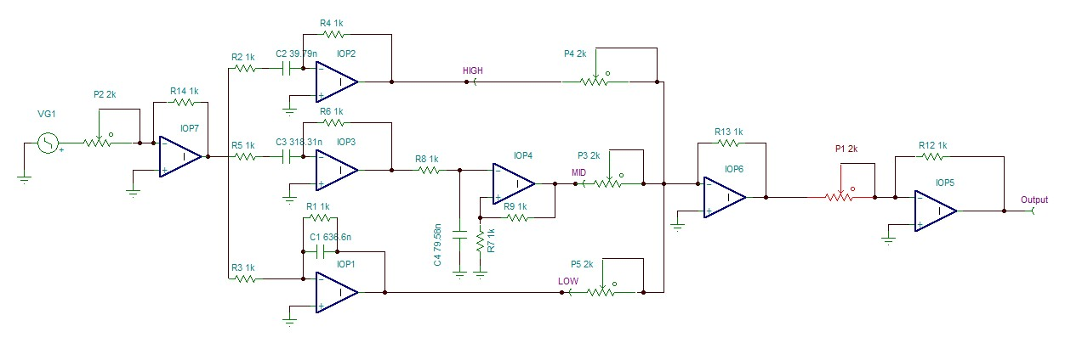

**Figure 1: Schematic inside of TINA**

From top to bottom in the filter section the circuit contains a high pass filter, a mid pass filter, and a low pass filter. As it is not possible to properly have each exact value for each capacitor, a close enough approximation was used instead. This approximation was then attenuated to resistors (These values can be found in the Appendix). The high pass filter for the first part of the midband, and the high pass filter, and the low pass filter use a standard design. The low pass part of the midband however uses an unconventional non-inverting op-amp and is then amplified by the resistors coming out of the positive edge. This design works as it is a passive low pass filter into a non-inverting op-amp. The gain for all the op-amps should be a unity gain, so all of the potentiometer would be in total control of gain. By dialing the potentiometer up or down, the gain of each band would vary.

This circuit system is aimed to have a lot of control over each section in the circuit. This design choice was dictated by the goal of the project to make sure that it works. For example the control system on the initial amplification system would not exist if the proper planning for circuit was made in expectance of a specific connection system. Instead the initial potentiometer exists specifically to amplify the first input signal at any value of multiplication.

### The PCB Design

The schematic was then recreated in DipTrace. As DipTrace has no PCB design for the potentiometers, three pin headers were used for every potentiometer. This is the same for the ground, input voltages, and power for the operational amplifiers but with two pin headers rather than three pin headers.

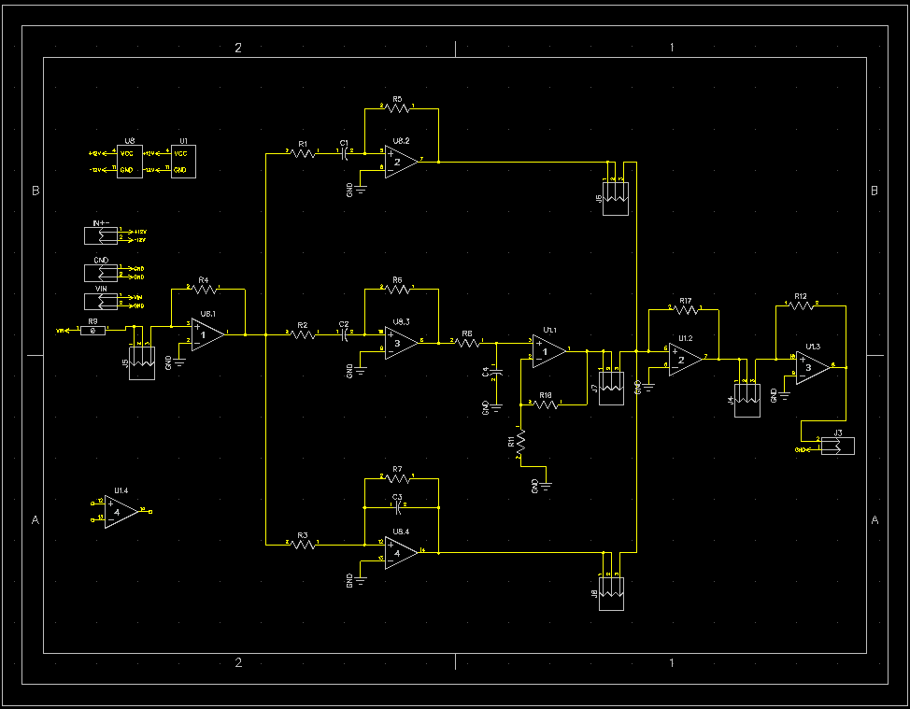

**Figure 2: Schematic inside of DipTrace**

The PCB had many issues connecting all of these components onto the quad op-amp LM324. As many of these components ended up in parallel with other components. Which led to a lot of ratline crossing. To avoid this the quad op-amps were placed horizontally to spread out all of the other passive components. Then to avoid more than 3 ratlines crossing, many of the components were connected through the backside of the PCB.

As the design was aimed more for fitting everything over a sleek design, the input signal and ground are grouped in between other capacitors and resistors. If this were to be redone, these two headers would be moved towards the edges of the PCB. This would allow for an auxiliary cord to easily attach onto the board. Rather than an awkward placement in the middle. The resistor placement as well as the capacitors would also have a uniform placement orientation for more pleasing presentation.

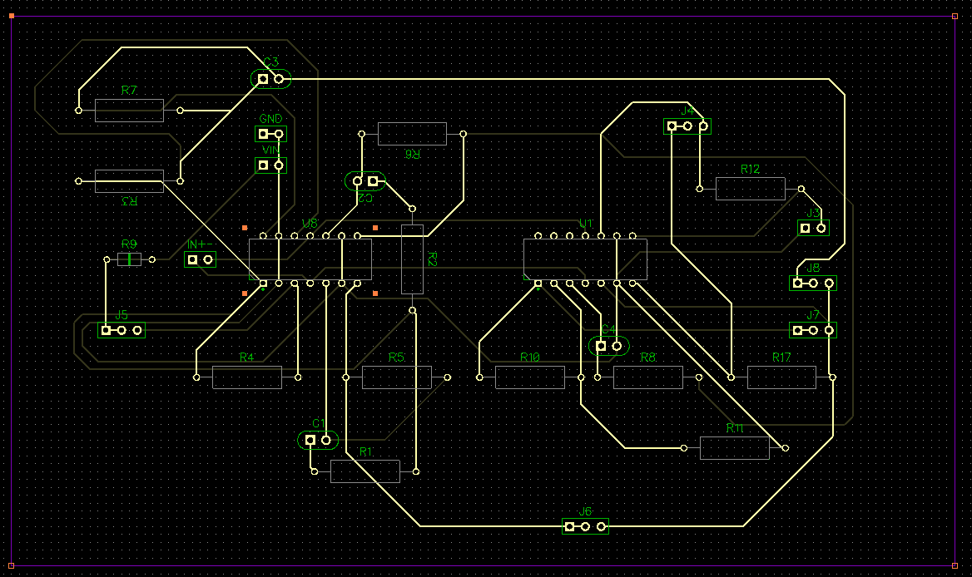

**Figure 3: Front side of PCB in DipTrace**

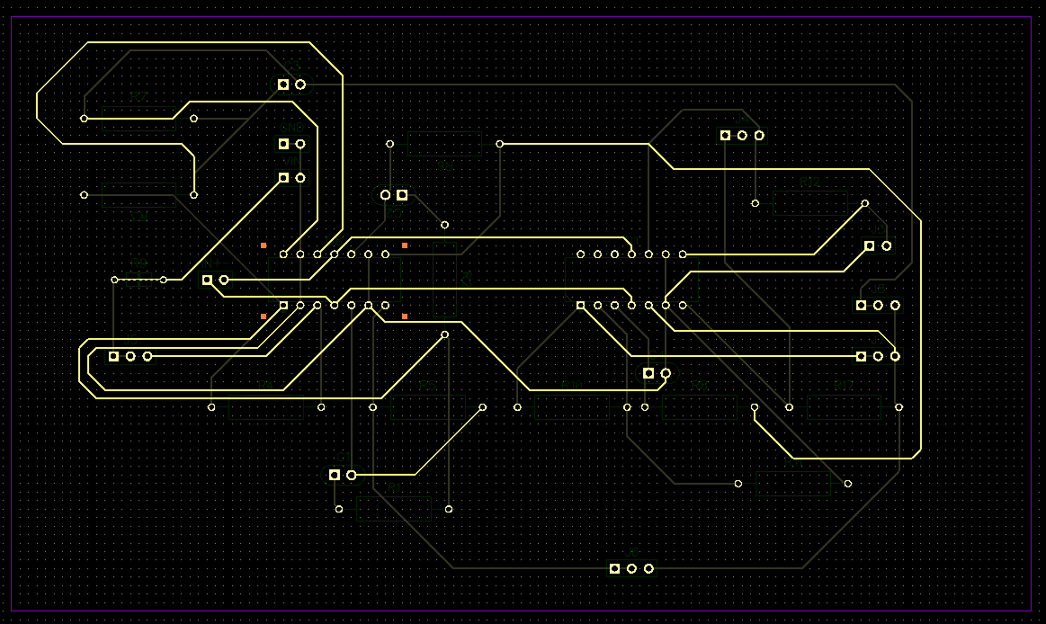

**Figure 4: Backside of PCB in DipTrace**

#### **Physical Design/Procedures**

### Setup of the Breadboard

The breadboard was modeled after the schematic design. Each part is separated in a colour code. The yellow represents the high pass, the orange for the low pass, and the green for the mid pass. Red was mostly reserved for any power, while all black wires were for ground. When there was not sufficient black wires, white wires were used instead. Any other colours were used for input gain and summing gain. The breadboard was composed of 5 potentiometers that were used to control the gain, the cutoff frequency for each band, and also for volume control.

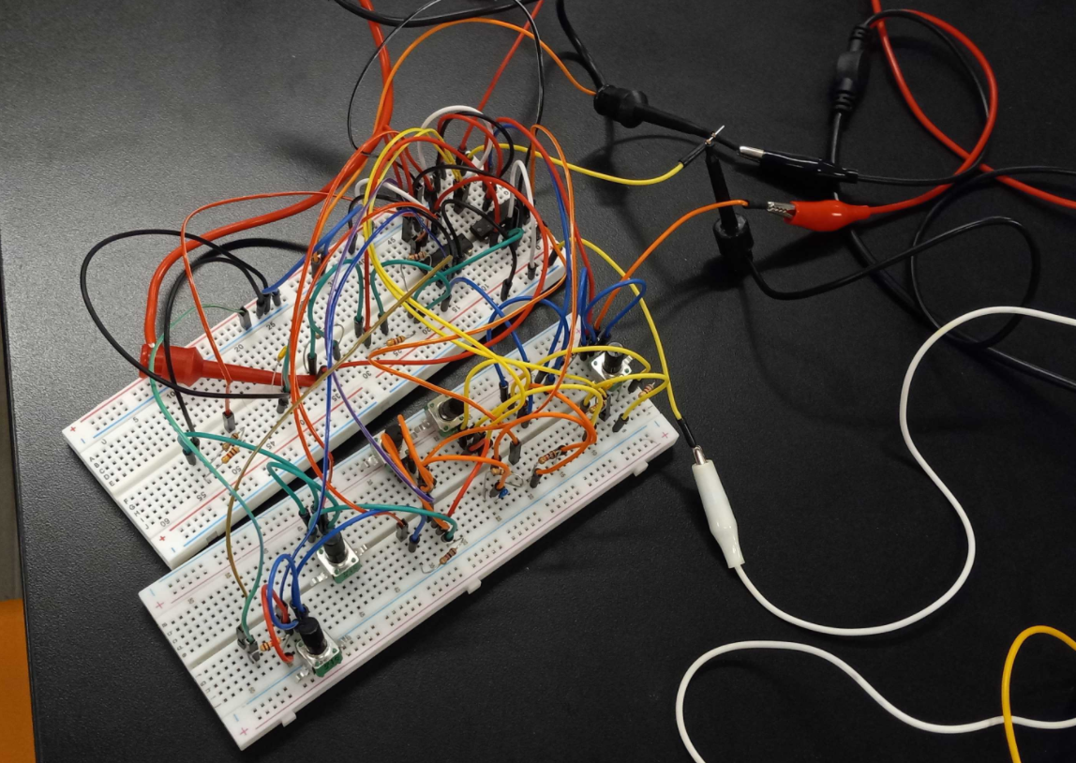

**Figure 5: Three Band Equalizer on a Breadboard**

### Setup of the Measuring equipment

The equipment used to measure the circuit was an oscilloscope to measure each band, a waveform generator to create a Vin, and a power supply to power the op-amp rails. The power supply used a recommended voltage setting as suggested by the datasheet. The waveform generator was used to make a sweep over the circuit and would be recorded on the oscilloscope. This would give the best visual representation of the frequency response found in each band. The oscilloscope also measured the output amplitude from the waveform generator to serve as a good comparison to the read frequency response.

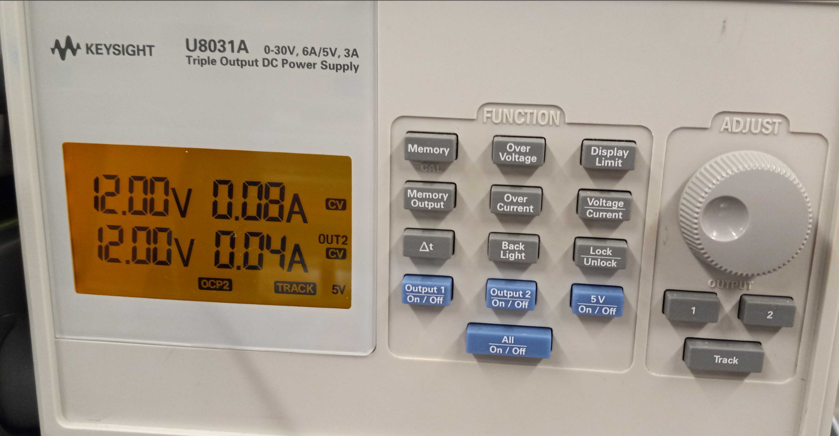

Figure 6: Settings of the Power Supply

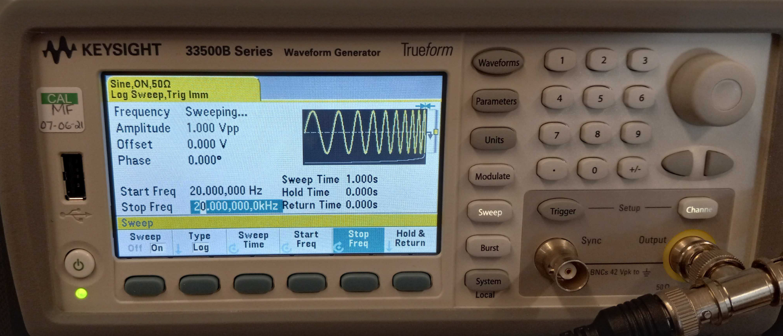

Figure 7: Settings of Waveform Generator

## Results

### Simulation

Within TINA the schematic was simulated. This simulation uses TINA’s built in AC Transfer Characteristic sweep. This sweeps over a range of frequencies and graphs the gain (dB) of the selected node points. These node points can be seen on Figure 1 where each node is labeled by their band. There is a node for the Low, High, and Midband pass. There is also one on the output to see if the potentiometers make a difference.

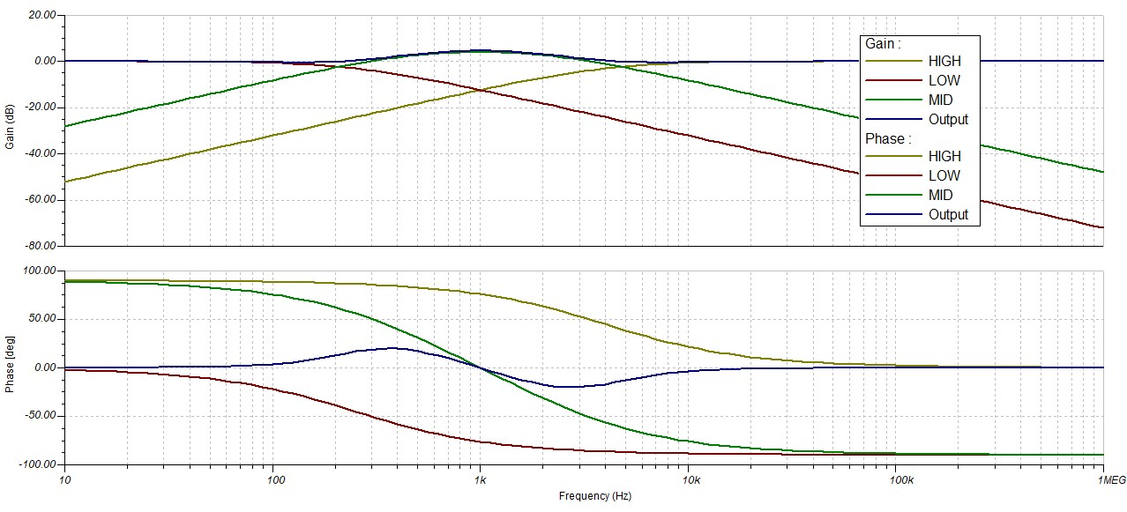

**Figure 8: Results of the TINA simulation**

As seen within the simulation the filters work as required. The low pass filter shows an atypical frequency response where the signal cuts off when the frequency increases. The high pass filter shows the same type of response but only in reverse. The midband pass filter also gives a nice two frequency cut off response. The only issue being that there is a slight amount of gain found on both the mid pass and the output itself.

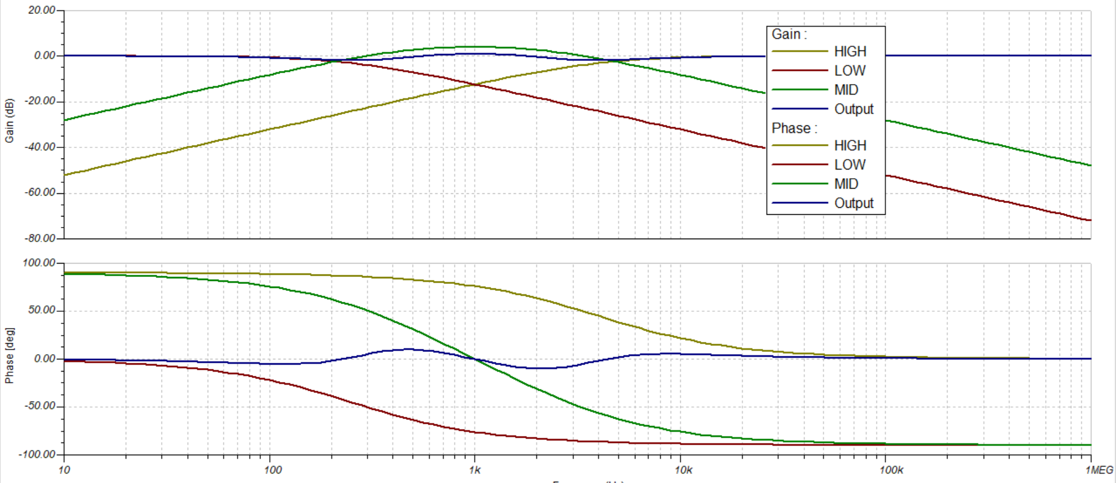

**Figure 9: TINA simulation when potentiometer is changed.**

The graph seen in Figure 9 shows the difference on the output when the potentiometer on the midband pass is set to a ratio of 20:80. This lowers the total output gain of the system and lowers the amplitude of the small wave seen within the phase. The midband pass sees the opposite effect. The gain goes up and the phase shifts slightly more.

### Breadboard Test

As stated in the setup of the measuring equipment, the oscilloscope is measuring the breadboard’s individual bands. The connection points were always set up with one being attached to the output and the other being right before the potentiometer of each band.

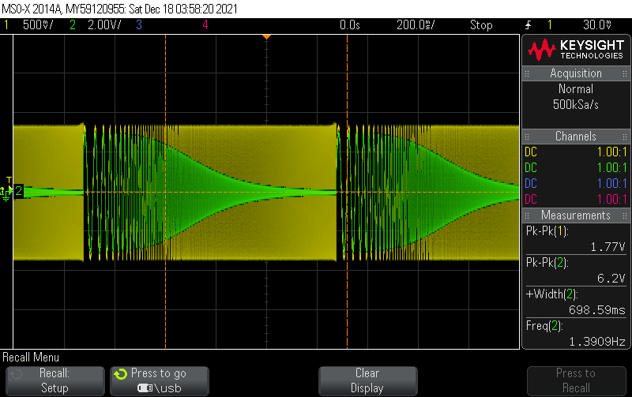

**Figure 10: Oscilloscope Recording of the Low Pass Filter**

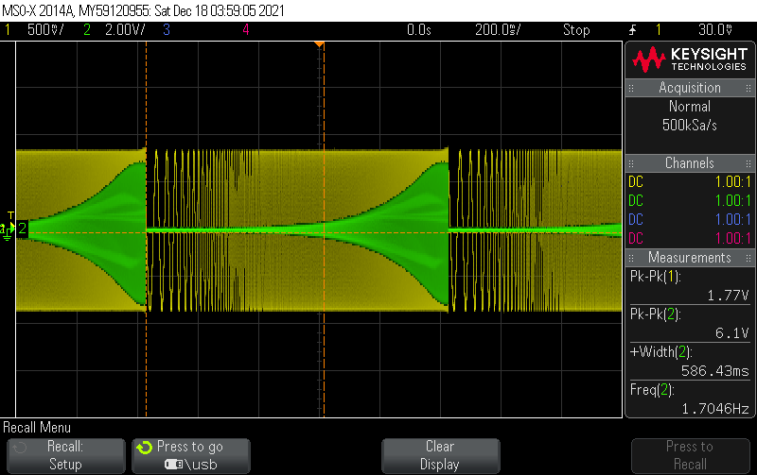

**Figure 11: Oscilloscope Recording of the High Pass Filter**

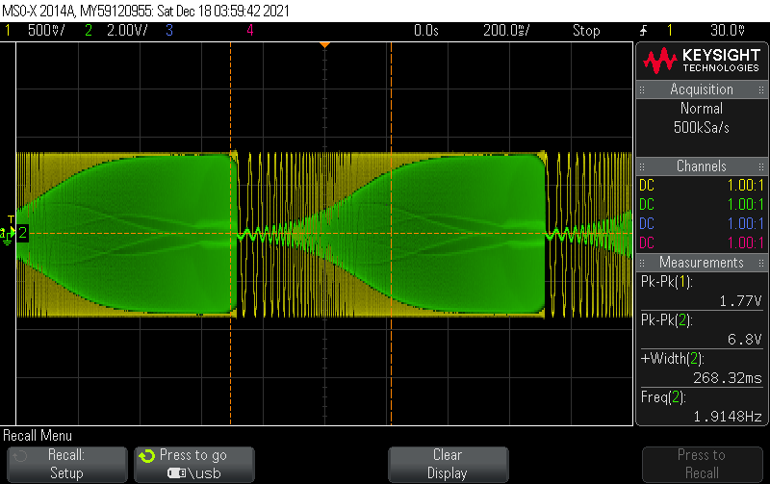

**Figure 12: Oscilloscope Recording of the Midband High Pass Filter**

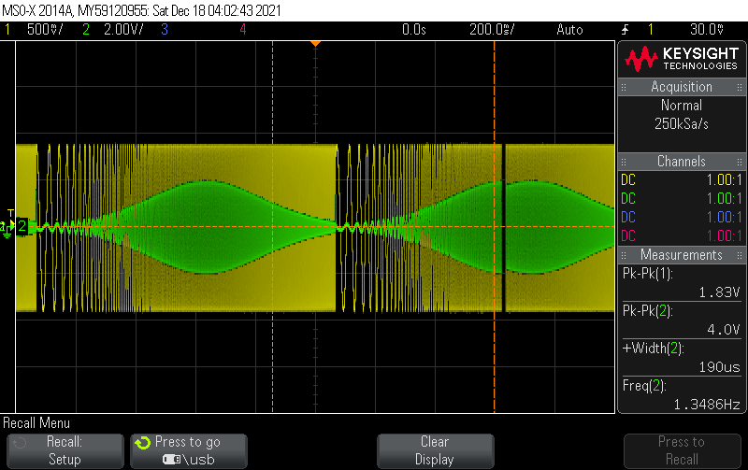

**Figure 13: Oscilloscope Recording of the Midband Low Pass Filter**

All of the filters exemplify the aimed frequency response. The low pass and high pass filters have the needed cutoff frequency response. The only issue with the breadboard’s test seems to be that the low pass filter seen in the midband pass is not standard. This filter does not show the aimed frequency response for a low pass filter. This is likely due to the fact that it follows up the high pass filter. Which gives it the quality of both. This means that the frequency response seen in Figure 13 is likely the midband pass filter frequency response. Which follows the atypical response where there are two cutoff frequencies.

## Conclusions

The frequency response of both the simulation and the breadboard test showed the needed cutoff response. The gain of the overall circuit had some strange issues that could have been due to either the capacitor values or the inherent problems seen inside all breadboards. Breadboards have so many components close to each other that it creates other components like inductors and capacitors within the board. If there was more time to print a PCB or to solder this on a Protoboard, then these issues would be avoided. Also connection points would be easier to measure over having to maneuver within the breadboard. The only advantage that a PCB would have over the Protoboard would be a more uniform design and no floating wires which can cause a lot of mechanical issues.

## Appendix

### Oscilloscope Settings

ANALOG:

Ch 1 Scale 500mV/, Pos 0.0V, Coup DC, BW Limit Off, Inv Off, Imp 1M Ohm

Probe 1.0000000 : 1, Skew 0.0s

Ch 2 Scale 2.00V/, Pos 0.0V, Coup DC, BW Limit Off, Inv Off, Imp 1M Ohm

Probe 1.0000000 : 1, Skew 0.0s

TRIGGER:

Sweep Mode Auto, Coup DC, Noise Rej Off, HF Rej Off, Holdoff 40.0ns

Mode Edge, Source Ch 1, Slope Rising, Level 30.00mV

HORIZONTAL:

Mode Normal, Ref Center, Main Scale 200.0ms/, Main Delay 0.0s

ACQUISITION:

Mode Normal, Realtime On, Vectors On, Persistence Off

### TINA Settings

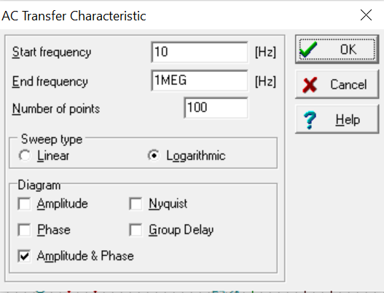

**Figure 14: AC Graph settings**

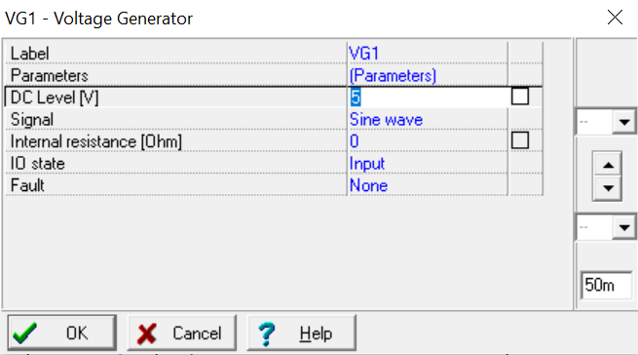

**Figure 15: Voltage Generator settings**

### Quad Op-Amp Datasheet

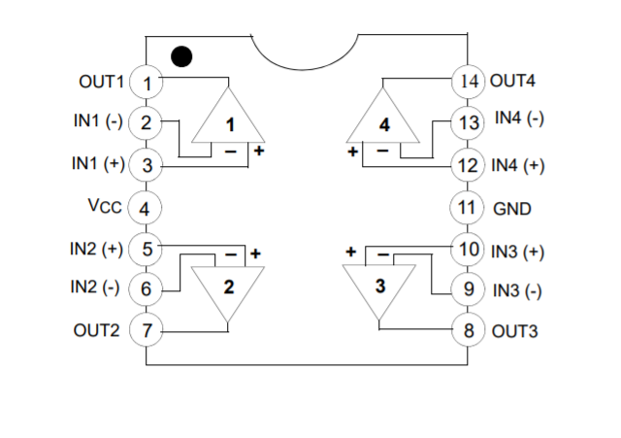

<https://datasheets.diptrace.com/fairchild/lm2902.pdf>

Figure 16: Picture of op-amp schematic

### Aimed frequency values

Low Pass Cut Off Frequency: 250hz

High Pass Cut Off Frequency: 4khz

Midband Pass Cut Off Range: 500hz-2khz

### Capacitor & Resistor values

Low Pass Capacitor: .68μF

Low Pass Resistor: 910Ω

High Pass Capacitor: .047μF

High Pass Resistor: 820Ω

Midband Low Capacitor: .068μF

Midband Low Resistor: 1.2kΩ

Midband High Capacitor: .33μF

Midband High Resistor: 1kΩ

Equations

$f_{c}=\frac{1}{τ}$

$C=\frac{1}{2πRf_{c}}$

$R=\frac{1}{2πCf_{c}}$